using System;

using System.Windows.Forms;

namespace Calcumalation

{

// A GUI program that measures a room volume by user input

// Written By: Sam Graham

// Written On: 3/31/2019

public partial class frmMain : Form

{

public frmMain()

{

InitializeComponent();

}

// handles calculate button click

private void btnCalculate_Click(object sender, EventArgs e)

{

double width = Convert.ToDouble(txtbxRoomWidth.Text);

double length = Convert.ToDouble(txtbxRoomLength.Text);

double height = Convert.ToDouble(txtbxRoomHeight.Text);

string calculatedMessage = string.Format("The room is {0} square feet and has a volume of {1} cubic feet",

Convert.ToString(width * length), Convert.ToString(calculateRoomVolume(width, length, height)));

lblCalculatedVolume.Visible = true;

lblCalculatedVolume.Text = (calculatedMessage) ;

}

private double calculateRoomVolume(double width, double length, double height)

{

double result = (width * length) * height;

return result;

}

}

}

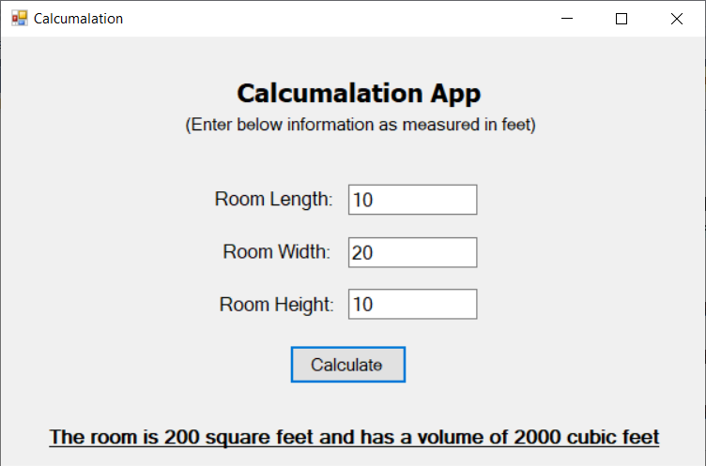

using System;

using static System.Console;

namespace Magic8Ball

{

/*

* Console program that asks a user if they want to spin a magic

* 8-ball. Random int is passed to a method that displays the

* message in that element location of a string array. Another method

* validates user input an appropriate response.

*/

// Written by: Samuel Graham, Tampa, FL USA

// Written On: 3/31/2019

class Program

{

static void Main(string[] args)

{

Random sumNum = new Random();

int spin8Ball;

string userResponse;

WriteLine("Would you like to spin the 8 ball? y/n");

userResponse = ReadLine();

checkUserInput(userResponse);

while (userResponse != "n")

{

spin8Ball = sumNum.Next(0, 5); // high value is array length. Only gets 0-4 randomly.

fortune8Ball(spin8Ball);

WriteLine("Would you like to spin the 8 ball? y/n");

userResponse = ReadLine();

checkUserInput(userResponse);

}

if (userResponse == "n")

{

// terminate this program execution

Environment.Exit(0);

}

}

// takes the random number generated in main, if array length changes alter variable in main.

static void fortune8Ball(int num)

{

// array of 8 ball responses

string[] fortune = { "The answer seems certain", "The future is cloudy",

"Ask again later", "Go do something productive", "Quit wasting time" };

WriteLine(fortune[num]);

}

// method to validate user input

static string checkUserInput(string checkingInput)

{

while (checkingInput != "y")

{

while (checkingInput != "n")

{

WriteLine("invalid input");

WriteLine("Would you like to spin the 8 ball ? y / n");

checkingInput = ReadLine();

}

}

return checkingInput;

}

}

}

**OUTPUT:**

